SQL 3

Create Statements for all tables 3

Common Queries used in program 4

Windows 4

Homepage: 4

Design 4

XAML 6

C# 6

Register page: 6

Design 7

XAML 9

C# 9

Login page: 9

Design 10

XAML 12

C# 12

Reset password: 12

Design 13

XAML 13

C# 13

Account: 13

Design 13

XAML 13

C# 13

Map: 13

Design 14

XAML 15

C# 15

Booking: 15

Design 16

XAML 17

C# 17

Visiting: 17

Design 18

XAML 19

C# 19

Contact us: 19

Design 20

XAML 20

C# 20

About us: 20

Design 21

XAML 23

C# 23

Information: 23

Design 24

XAML 26

C# 26

Discount: 26

Design 27

XAML 28

C# 29

Policy: 29

Design 29

XAML 31

C# 31

Term and conditions: 31

Design 32

XAML 34

C# 34

Resources and Assets 34

Assets used + Sources 34

References 34

# SQL

## Create Statements for all tables

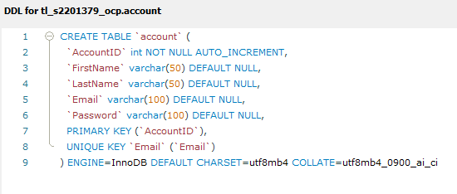

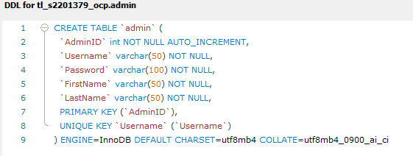

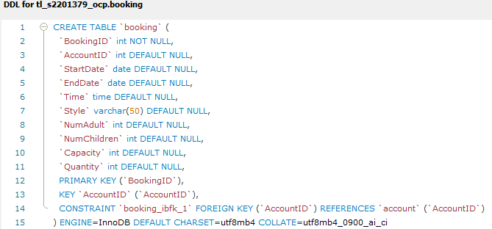

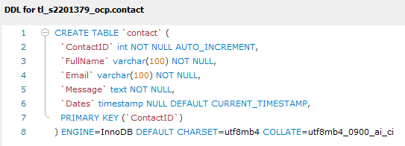

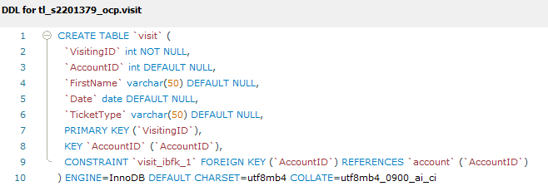

## Common Queries used in program

# Windows

## Homepage:

### Design

The main window is the first thing you see when starting an application in a Windows system, acting as the user's main interface for interaction. I have chosen to creat a simplistic and minimalist design for the home page, this is to not over stilmulate the user and detaer users from using the aplication. It contains different components, such as:

* **Account, login, Register**: I have chosen to display these subheadings to make it easier fot the user to access detail and amend them to there disgretion.
* **Booking, Discount, visiting**: A collection of the application that are what I espect to atract consumers/users’ attention and I have chosen to incorperate this into my page to create efficeny but to grab users’ attention prom the moment they open the application.
* **Map, information, about us**: these headins are found on the page to aid users that may need help or require Knowledge about RZA, I have chosen to put these headins on the home page for the betterment of the overal user expirance.
* **Contact us, policy, term and conditons**: the reason I have included these interfaces into the design of this page is so that if users want to contact oor read aout legistation and what we do with there data, this creates tranpaciy but also an open relation for b2c operations.

V1

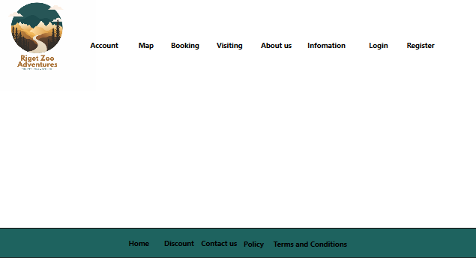

V2

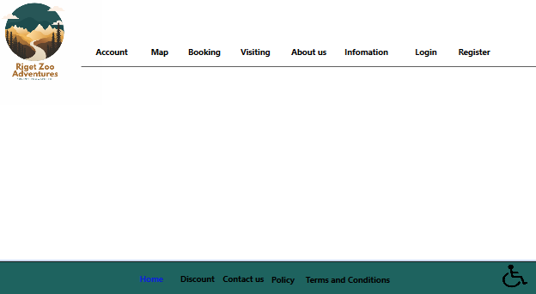

In this version I have thought of users needs and have included a shoortcut for users to reach a panel that displays accesability features the user can use to customise there exiprance.

V3

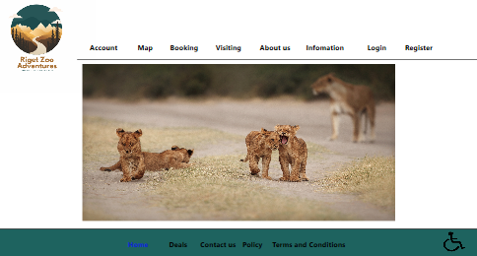

I have dicided to input an image in the center of the page to make the window appear more visually pleasing to users.

### XAML

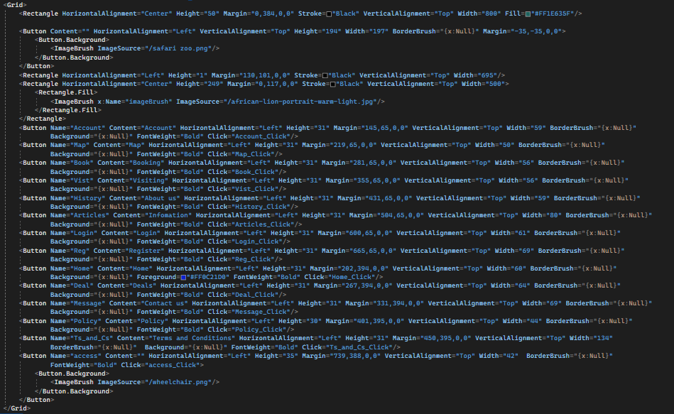

### C#

## Register page:

The "Register" window is designed to allow new users to create an account with Riget Zoo Adventures. This page features a simple and user-friendly layout, allowing users to easily input their personal details to become a new member.

The window contains several key components:

Header: A green bar at the top of the window, representing the Riget Zoo Adventures brand.

Navigation Buttons: A series of clickable buttons for easy navigation to various sections of the page, including Account, Map, Booking, and more.

Accessibility Button: A wheelchair icon button, providing quick access to accessibility options.

First Name Input: A TextBox for users to input their first name.

Last Name Input: A TextBox for users to input their last name.

Email Input: A TextBox for users to input their email address associated with their account.

Password Input: A PasswordBox for users to input their new password.

Confirm Password Input: A PasswordBox for users to confirm their new password.

Label Text: Descriptive labels for each input field, guiding users on what information to provide.

Submit Button: A button for users to submit their details and complete the registration process.

Already Have an Account Link: A button for users who already have an account to navigate to the login page.

By presenting the information and input fields in a clear and organized manner, the "Register" window aims to create a straightforward and secure experience for users, allowing them to create a new account and become a member of the Riget Zoo Adventures community quickly and easily.

### Design

V1



V2

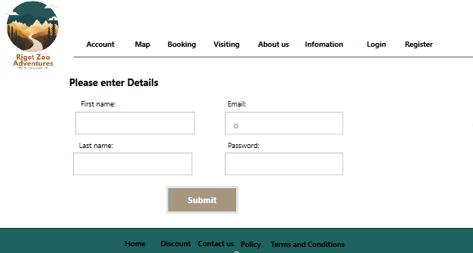

V3

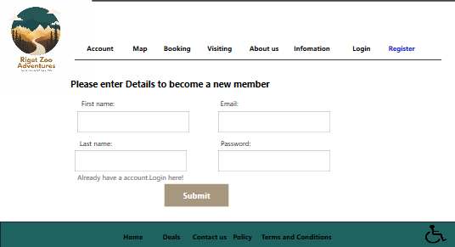

### XAML

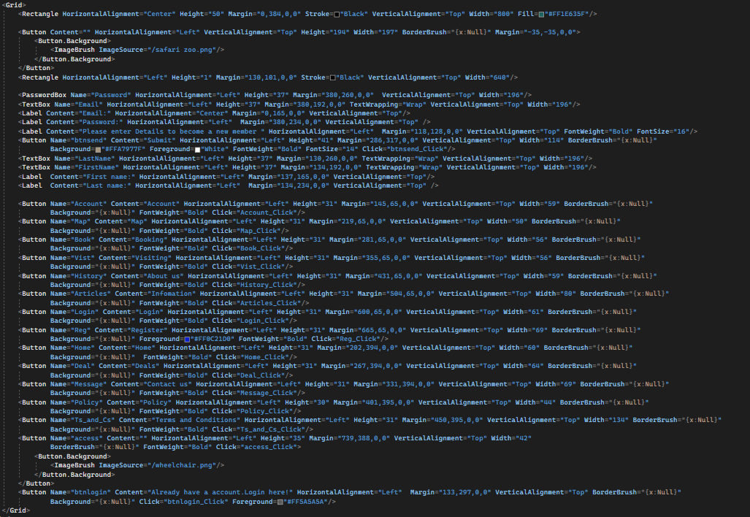

### C#

## Login page:

The Login window is designed to help users access to their account by entering details e.g password. This page features a simple and user-friendly layout, allowing users to easily input their new password and confirm it.

The window contains six key components:

Header: A green bar at the top of the window, representing the Riget Zoo Adventures brand.

Navigation Buttons: A series of clickable buttons for easy navigation to various sections of the page, including Account, Map, Booking, and more.

Accessibility Button: A wheelchair icon button, providing quick access to accessibility options.

Email Input: A TextBox for users to input their email address associated with their account.

Password Input: A PasswordBox for users to input their password.

Label Text: Descriptive labels for each input field, guiding users on what information to provide.

Confirm Button: A button for users to submit their new password and confirm the reset process.

By presenting the information and input fields in a clear and organized manner, the login window aims to create a straightforward and secure experience for users, allowing them to quickly and easily login and gain access to their account.

### Design

V1



V2

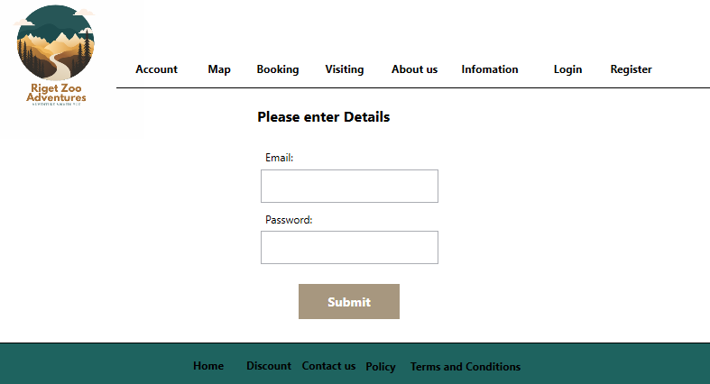

V3

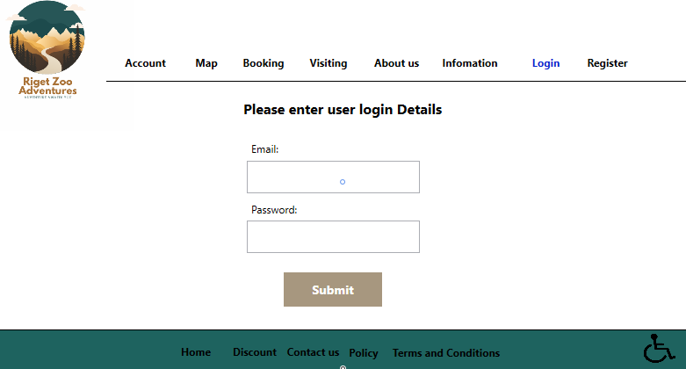

V4

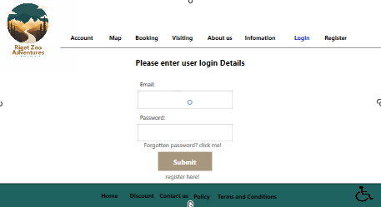

### XAML

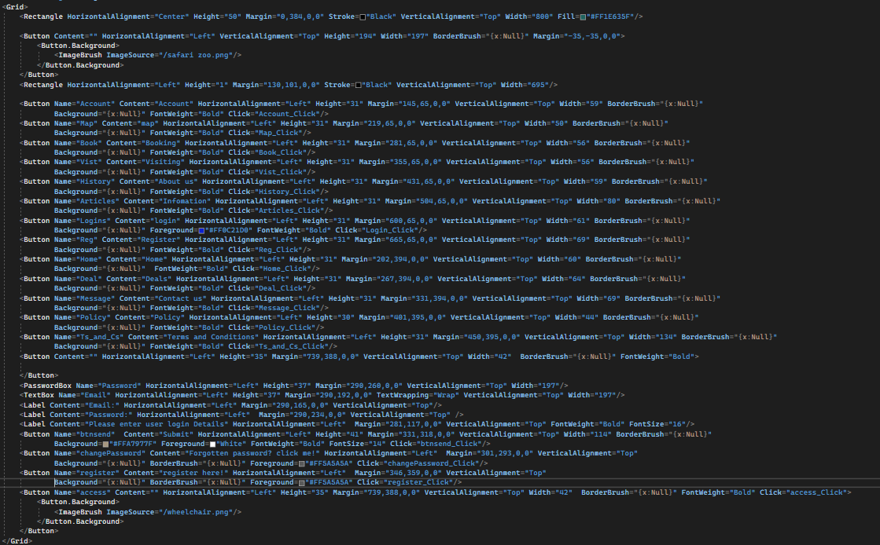

### C#

## Reset password:

The "Reset Password" window is designed to help users regain access to their account by resetting their password. This page features a simple and user-friendly layout, allowing users to easily input their new password and confirm it.

The window contains several key components:

Header: A green bar at the top of the window, representing the Riget Zoo Adventures brand.

Navigation Buttons: A series of clickable buttons for easy navigation to various sections of the page, including Account, Map, Booking, and more.

Accessibility Button: A wheelchair icon button, providing quick access to accessibility options.

Email Input: A TextBox for users to input their email address associated with their account.

Password Input: A PasswordBox for users to input their new password.

Confirm Password Input: A PasswordBox for users to confirm their new password.

Label Text: Descriptive labels for each input field, guiding users on what information to provide.

Confirm Button: A button for users to submit their new password and confirm the reset process.

By presenting the information and input fields in a clear and organized manner, the "Reset Password" window aims to create a straightforward and secure experience for users, allowing them to reset their password and regain access to their account quickly and easily.

### Design

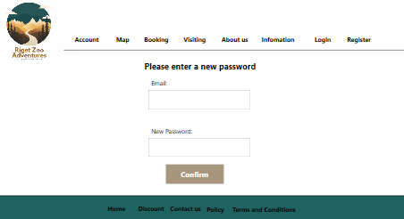

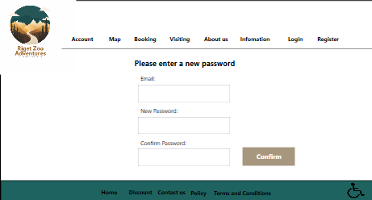

### XAML

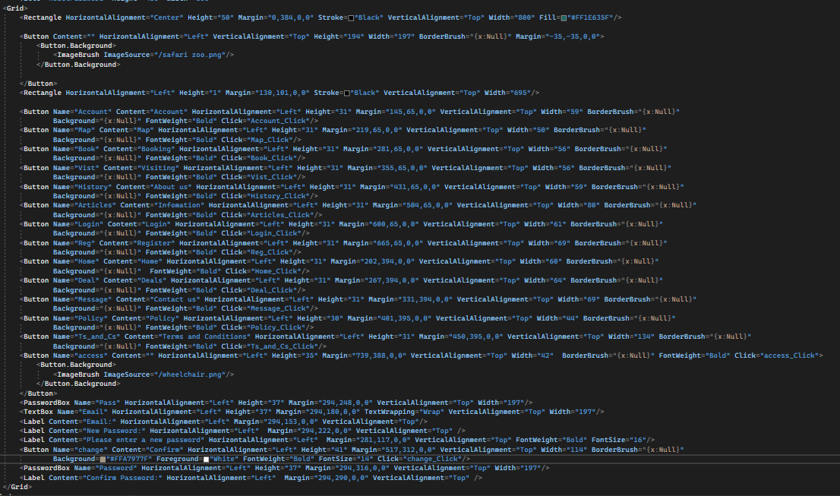

### C#

## Account:

### Design

### XAML

### C#

## Map:

The "Map" window is designed to provide users with a visual representation of Riget Zoo Adventures, allowing them to explore the park's layout and attractions. This page features a clear and organized layout, with a map of the park taking center stage.

The window contains several key components:

Header: A green bar at the top of the window, representing the Riget Zoo Adventures brand.

Navigation Buttons: A series of clickable buttons for easy navigation to various sections of the page, including Account, Visiting, Booking, and more.

Accessibility Button: A wheelchair icon button, providing quick access to accessibility options.

Map: A rectangular map of Riget Zoo Adventures, showcasing the park's layout and attractions.

By presenting the map in a clear and concise manner, the "Map" window aims to create an engaging and user-friendly experience for users, encouraging them to explore the park's offerings and plan their visit to Riget Zoo Adventures.

### Design

V1



V2

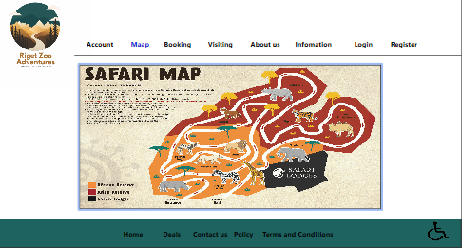

V2

In this version I have thought of users needs and have included a shoortcut for users to reach a panel that displays accesability features the user can use to customise there exiprance.

### XAML

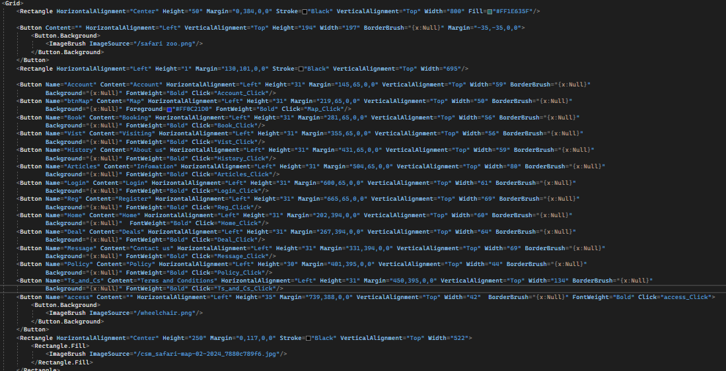

### C#

## Booking:

The "Booking" window is designed to allow users to make reservations for their visit to Riget Zoo Adventures. This page features a clear and organized layout, allowing users to easily input their desired dates, style, and number of guests.

The window contains several key components:

Header: A green bar at the top of the window, representing the Riget Zoo Adventures brand.

Navigation Buttons: A series of clickable buttons for easy navigation to various sections of the page, including Account, Map, Visiting, and more.

Accessibility Button: A wheelchair icon button, providing quick access to accessibility options.

Input Fields: Date pickers for users to select their start and end dates, a text box for entering the number of adults, a text box for entering the number of children, a combo box for selecting the style of their visit, and a combo box for selecting the room.

Labels: Labels displaying the prompts "Start Date:", "End Date:", "Style:", "Number of Adults:", "Number of Children:", and "Avaliblity" to guide users in filling out the input fields.

Checkbox: A checkbox for users to indicate if they require wheelchair accessibility.

Continue Button: A button labeled "continue" for users to proceed to the next step in the booking process.

By presenting the booking information in a clear and concise manner, the "Booking" window aims to create an engaging and user-friendly experience for users, encouraging them to make reservations for their visit to Riget Zoo Adventures.

### Design

V1



V2

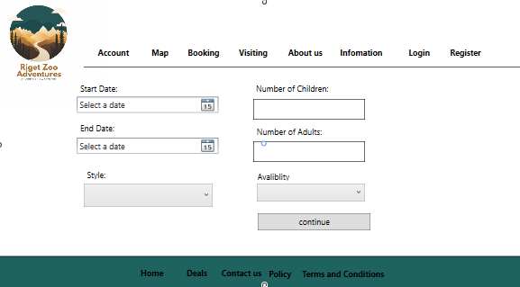

V3

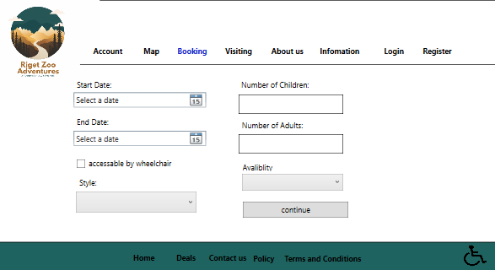

In this version I have thought of users needs and have included a shoortcut for users to reach a panel that displays accesability features the user can use to customise there exiprance.

V4

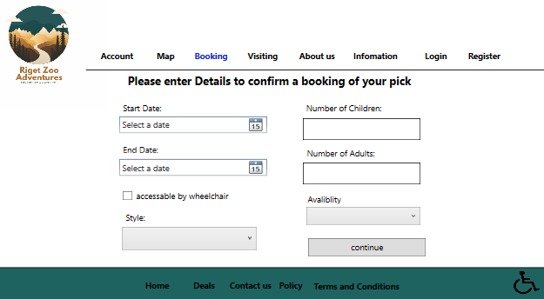

### XAML

### C#

## Visiting:

The "Visiting" window is designed to help users plan and book their visit to Riget Zoo Adventures (RZA). This page features a simple and intuitive layout, allowing users to easily input their desired visit details and proceed with the booking process.

The window contains several key components:

Header: A green bar at the top of the window, representing the RZA brand.

Navigation Buttons: A series of clickable buttons for easy navigation to various sections of the page, including Account, Map, Booking, and more.

Accessibility Button: A wheelchair icon button, providing quick access to accessibility options.

Visit Details: A section for users to input their desired visit date, type, and number of guests.

The visit details section includes:

Date: A DatePicker for users to select their preferred visit date.

Type: A ComboBox with predefined visit types (e.g., general admission, guided tour, etc.).

Number of Guests: A TextBox for users to input the number of guests they plan to bring.

Additionally, the window contains:

Continue Button: A button for users to proceed with their booking after inputting their visit details.

By presenting the information and input fields in a clear and organized manner, the "Visiting" window aims to create an efficient and user-friendly booking experience, allowing users to plan their visit quickly and easily to Riget Zoo Adventures.

### Design

V1



V2

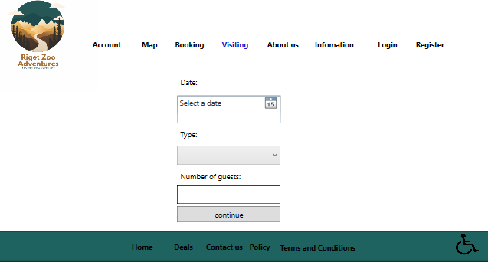

V3

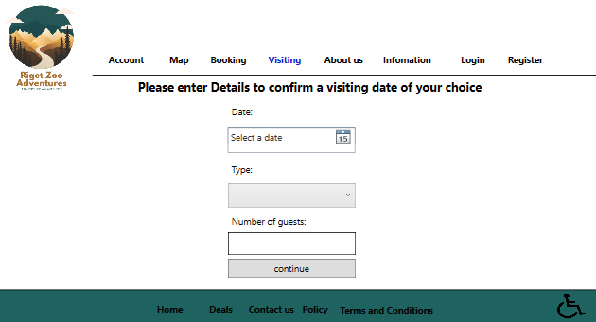

### XAML

### C#

## Contact us:

The "Contact Us" window is designed to allow users to get in touch with Riget Zoo Adventures for any inquiries, feedback, or support. This page features a clear and organized layout, allowing users to easily input their contact information and message.

The window contains several key components:

Header: A green bar at the top of the window, representing the Riget Zoo Adventures brand.

Navigation Buttons: A series of clickable buttons for easy navigation to various sections of the page, including Account, Map, Booking, and more.

Accessibility Button: A wheelchair icon button, providing quick access to accessibility options.

Input Fields: Three input fields for users to enter their email address, location, and message.

Labels: Labels displaying the prompts "Enter email:", "Enter message:", and "Location" to guide users in filling out the input fields.

Submit Button: A button labeled "submit" for users to send their inquiries or feedback to Riget Zoo Adventures.

Social Media Icon: An image displaying social media icons, providing users with alternative ways to connect with Riget Zoo Adventures.

By presenting the contact information in a clear and concise manner, the "Contact Us" window aims to create an engaging and user-friendly experience for users, encouraging them to reach out to Riget Zoo Adventures for any questions or concerns they may have.

#### Design

#### XAML

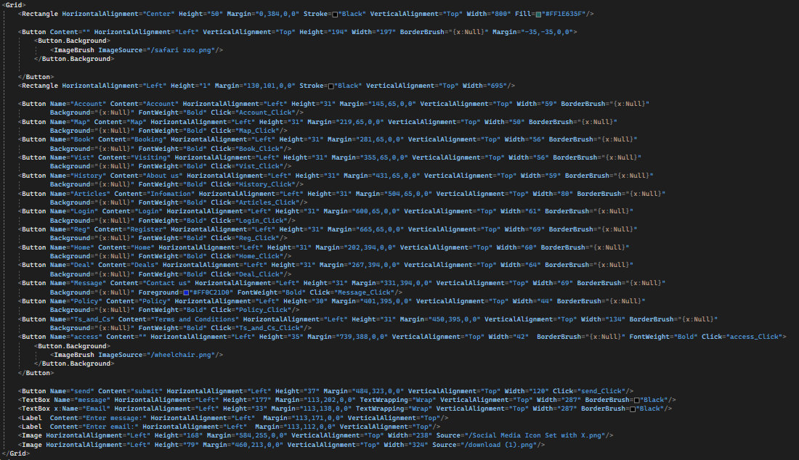

#### C#

## About us:

The About Us window is a dedicated page for users to learn about Riget Zoo Adventures (RZA). This page is designed to provide essential information in a clear and concise manner, making it accessible for users of all ages and backgrounds.

The window contains several key components:

Header: A green bar at the top of the window, representing the RZA brand.

Navigation Buttons: A series of clickable buttons for easy navigation to various sections of the page, including Account, Map, Booking, Visiting, and more.

Accessibility Button: A wheelchair icon button, providing quick access to accessibility options.

Content Area: The main section of the page, containing detailed information about RZA, including its mission, story, and various attractions.

The content area is organized into several subsections:

Mission Statement: A brief description of RZA's purpose and goals in promoting wildlife conservation and education.

History: A summary of RZA's founding and growth over the years, highlighting its commitment to wildlife and conservation.

Exploration: An invitation for users to discover and learn about the diverse range of animals and exhibits at RZA.

Conservation and Education: A statement about RZA's dedication to conservation efforts and educational programs, fostering a deeper connection between humans and the natural world.

Invitation: A call to action, encouraging users to embark on their own RZA adventure and contribute to the organization's mission.

By presenting the information in a simple and organized manner, the "About Us" window aims to create an engaging and informative user experience, allowing users to better understand and appreciate Riget Zoo Adventures.

### Design

V1



V2

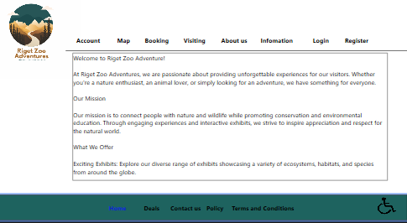

In this version I have thought of users needs and have included a shoortcut for users to reach a panel that displays accesability features the user can use to customise there exiprance.

V3

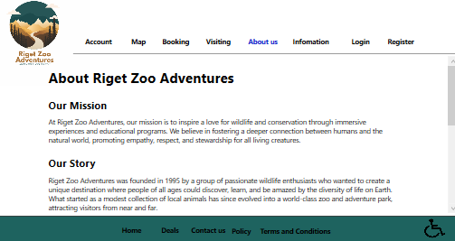

### XAML

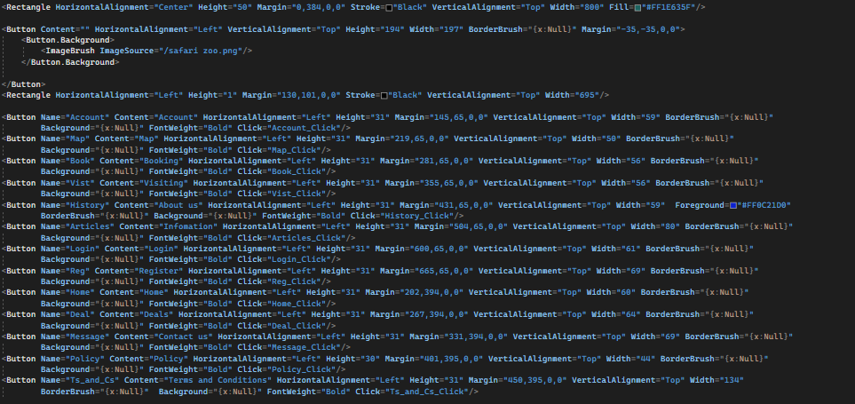

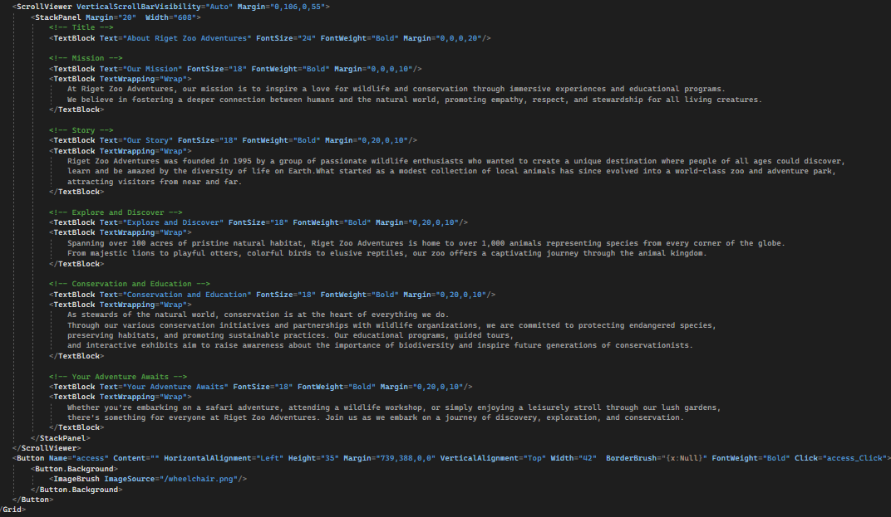

### C#

## Information:

The "Information" window is designed to provide users with interesting facts and information about various animals found in Riget Zoo Adventures. This page features a clear and organized layout, allowing users to easily access and learn about different species.

The window contains several key components:

Header: A green bar at the top of the window, representing the Riget Zoo Adventures brand.

Navigation Buttons: A series of clickable buttons for easy navigation to various sections of the page, including Account, Map, Booking, and more.

Accessibility Button: A wheelchair icon button, providing quick access to accessibility options.

Animal Buttons: Six clickable animal images (Lion, Tiger, Jaguar, Elephant, Rhino, and Wild Dogs) that users can click to learn more about each species.

Label Text: Descriptive labels for each animal image, guiding users on what animals are available for exploration.

By presenting the animal information in an engaging and interactive manner, the "Information" window aims to create an enjoyable and educational experience for users, encouraging them to learn more about the diverse wildlife found in Riget Zoo Adventures.

### Design

V1



V2

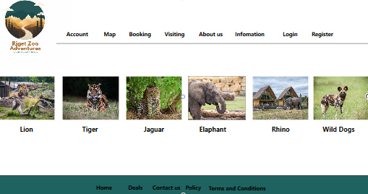

V3

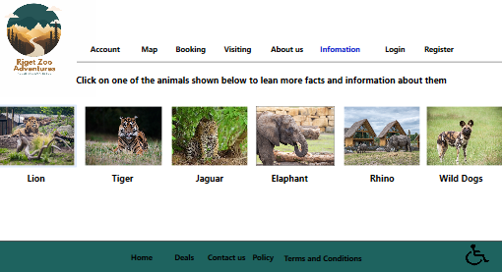

In this version I have thought of users needs and have included a shoortcut for users to reach a panel that displays accesability features the user can use to customise there exiprance.

### XAML

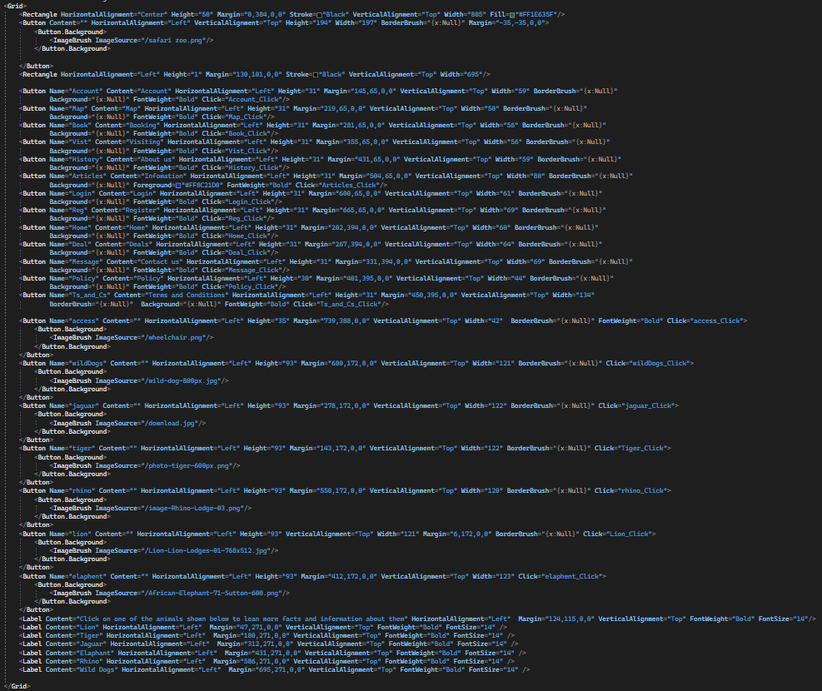

### C#

## Discount:

The "Discount" window is designed to provide users with information about ongoing discounts and special offers available at Riget Zoo Adventures. This page features a clear and organized layout, allowing users to easily access and understand the available deals.

The window contains several key components:

Header: A green bar at the top of the window, representing the Riget Zoo Adventures brand.

Navigation Buttons: A series of clickable buttons for easy navigation to various sections of the page, including Account, Map, Booking, and more.

Accessibility Button: A wheelchair icon button, providing quick access to accessibility options.

Discount Images and Labels: Two sets of images, rectangles, and labels displaying the available discounts, such as "Save up to 25% off on Day Pass When you spend £20" and "Save up to 40% on first time at RZA When you spend £10".

Deals Label: A label displaying the text "Current Deals:" to inform users about the available discounts.

By presenting the discount information in a clear and concise manner, the "Discount" window aims to create an engaging and informative experience for users, encouraging them to take advantage of the special offers available at Riget Zoo Adventures.

### Design

V1

#

V2

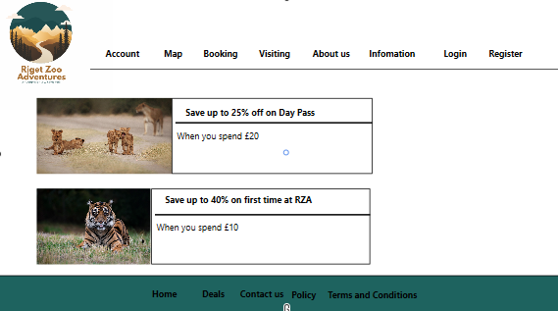

V3

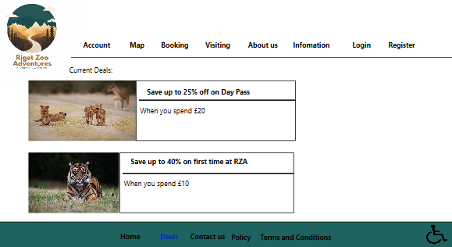

In this version I have thought of users needs and have included a shoortcut for users to reach a panel that displays accesability features the user can use to customise there exiprance.

### XAML

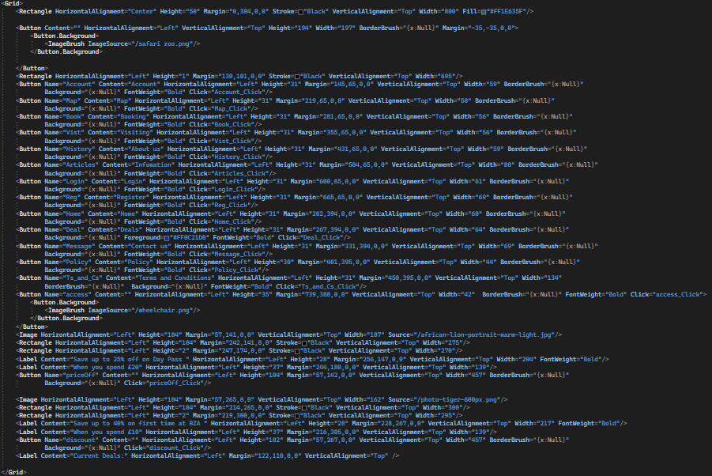

### C#

## Policy:

The "Policy" window is designed to provide users with essential information about Riget Zoo Adventures' privacy policy. This page features a clear and organized layout, allowing users to easily understand how their personal information is collected, used, and protected.

The window contains several key components:

Header: A green bar at the top of the window, representing the Riget Zoo Adventures brand.

Navigation Buttons: A series of clickable buttons for easy navigation to various sections of the page, including Account, Map, Booking, and more.

Accessibility Button: A wheelchair icon button, providing quick access to accessibility options.

ScrollViewer: A section containing the privacy policy text, allowing users to scroll through the content.

The privacy policy text includes essential information on:

Information We Collect

How We Use Your Information

Data Security

Disclosure of Information

Your Choices

Changes to This Policy

By presenting the privacy policy in a clear and concise manner, the "Policy" window aims to create a transparent and trustworthy experience for users, ensuring they are well-informed about how their personal information is handled when using Riget Zoo Adventures' services.

### Design

V1



V2

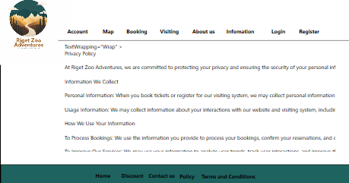

V3

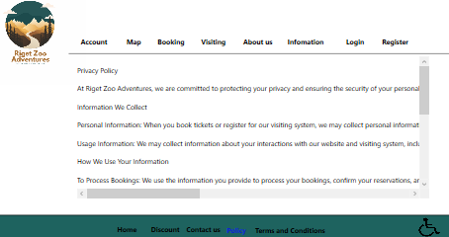

In this version I have thought of users needs and have included a shoortcut for users to reach a panel that displays accesability features the user can use to customise there exiprance.

### XAML

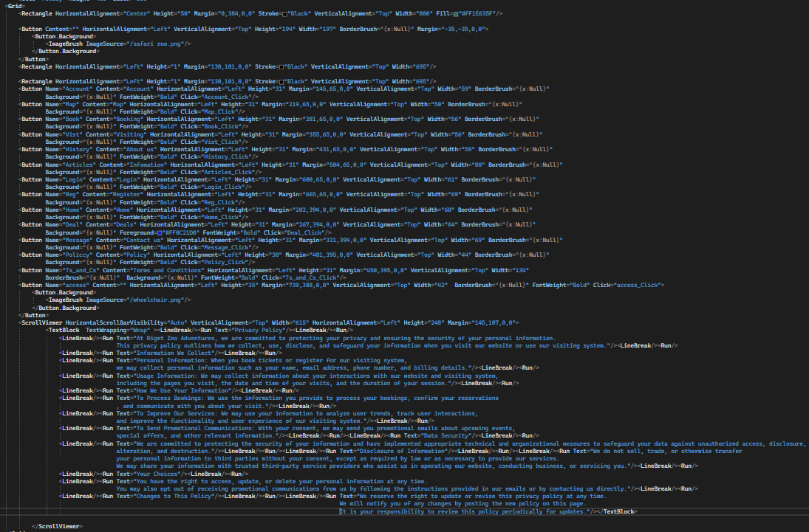

### C#

## Term and conditions:

The "Terms and Conditions" window is designed to provide users with essential information regarding their visit to Riget Zoo Adventures (RZA). This page features a clear and organized layout, allowing users to easily understand the rules, regulations, and policies associated with their visit.

The window contains several key components:

Header: A green bar at the top of the window, representing the RZA brand.

Navigation Buttons: A series of clickable buttons for easy navigation to various sections of the page, including Account, Map, Booking, and more.

Accessibility Button: A wheelchair icon button, providing quick access to accessibility options.

ScrollViewer: A section containing the terms and conditions text, allowing users to scroll through the content.

The terms and conditions text includes essential information on:

Booking

Payment

Cancellation and Refund Policy

Modification of Booking

Visitor Responsibility

Conduct

Health and Safety

Liability

Personal Belongings

Force Majeure

Legal Jurisdiction

By presenting the terms and conditions in a clear and concise manner, the "Terms and Conditions" window aims to ensure that users are well-informed about their visit to Riget Zoo Adventures, promoting a safe and enjoyable experience for all visitors.

### Design

V1



V2

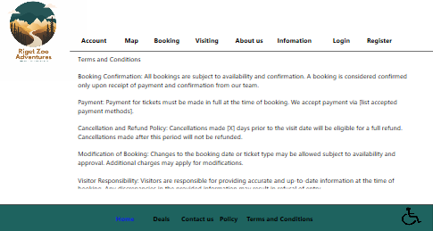

In this version I have thought of users needs and have included a shoortcut for users to reach a panel that displays accesability features the user can use to customise there exiprance.

V3

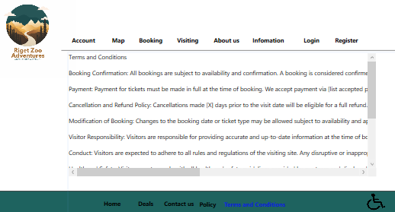

### XAML

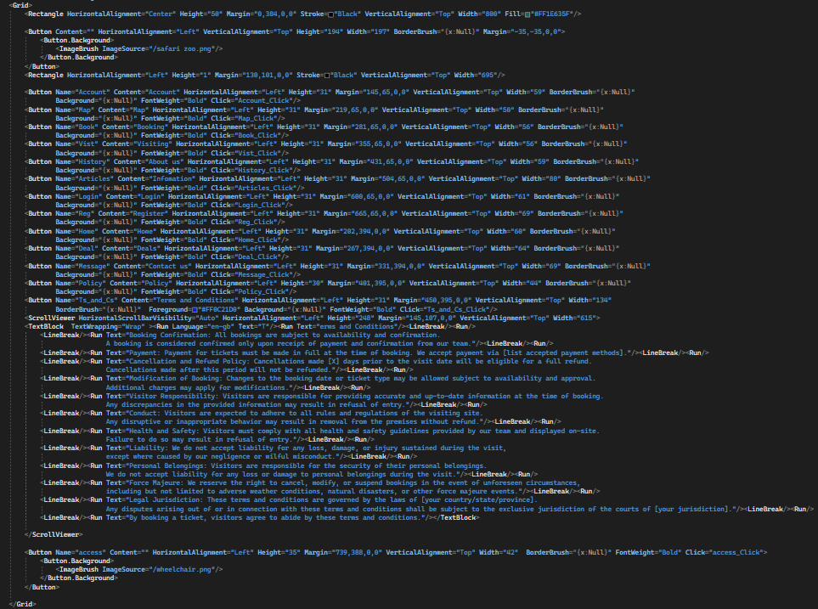

### C#

# Resources and Assets

## Assets used + Sources

(Any images used and links to where you found them)

## References

(Links to any sources of information you used e.g., GitHub / stack overflow)

<https://www.gvi.co.uk/blog/smb-10-cool-jaguar-facts/>

<https://www.folly-farm.co.uk/zoo/meet-the-zoo-animals/eastern-black-rhino/>

<https://www.folly-farm.co.uk/zoo/meet-the-zoo-animals/african-lion/>

<https://www.fauna-flora.org/species/african-wild-dog/>

<https://www.elephantparade.com/blog/10-facts-about-elephants-that-will-surprise-you>

<https://www.tigerstealive.com/tiger-who-came-to-tea-blog/10-fun-facts-about-tigers-you-didn-t-know>